
Quarterly Volunteering and Donating Indicators
This update provides information on key indicators of volunteering and donating in New Zealand up to the quarter ending 31 December 2012.

For more information about these indicators, please see previous releases. Also, please find a complete list of Quarterly Volunteering and Donating Indicators from the March 2010 quarter onwards attached at the end of this report.
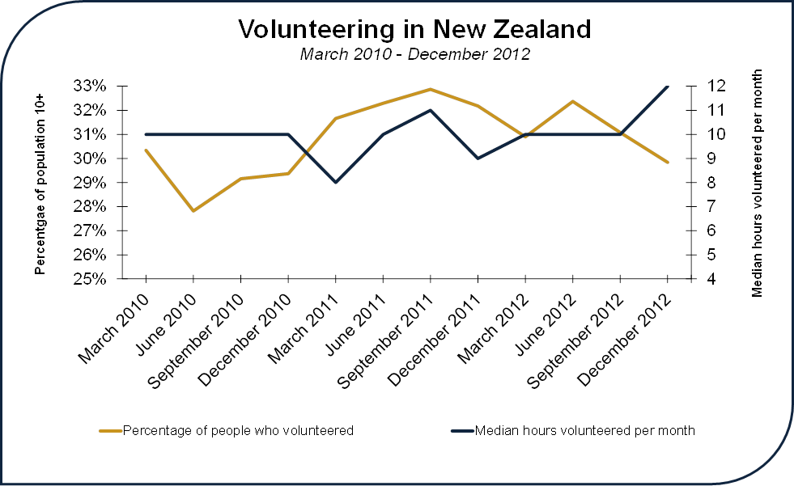
Since June 2012, the percentage of people volunteering in New Zealand has generally trended downwards while the median hours volunteered per month has remained generally stable at around 10 hours.

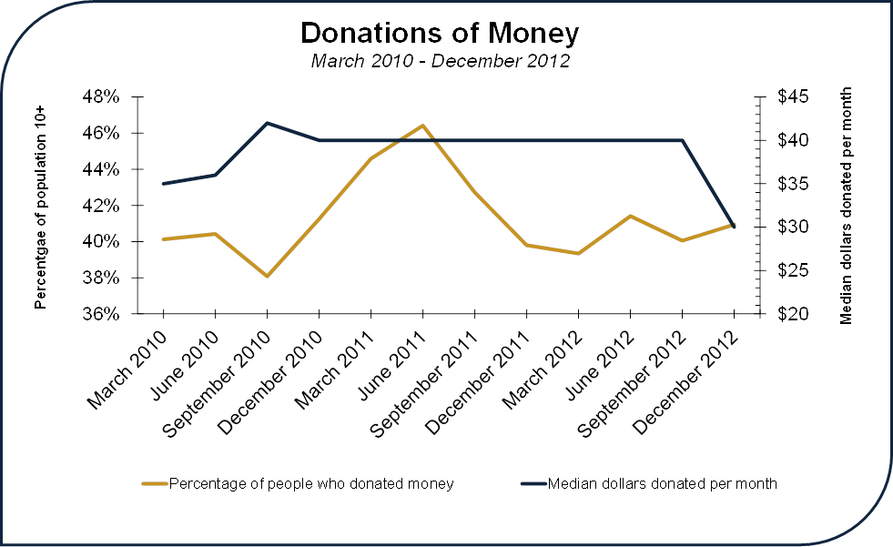
The percentage of the population aged 10 years and older donating money ranged from 38 per cent in the September 2010 quarter to 46 per cent in the June 2011 quarter. The median amount of money donated declined by $10 to $30 in the December 2012 quarter, after it had remained stable at $40 per month during the previous eight quarters.
The percentage of people donating money declined over the three quarters between June 2011 and December 2011, dropping from a high of 46 per cent in that quarter to 39 per cent in March 2012. As noted in previous reports, the increase in donations from September 2010 to June 2011 is most likely related to the Christchurch earthquakes.

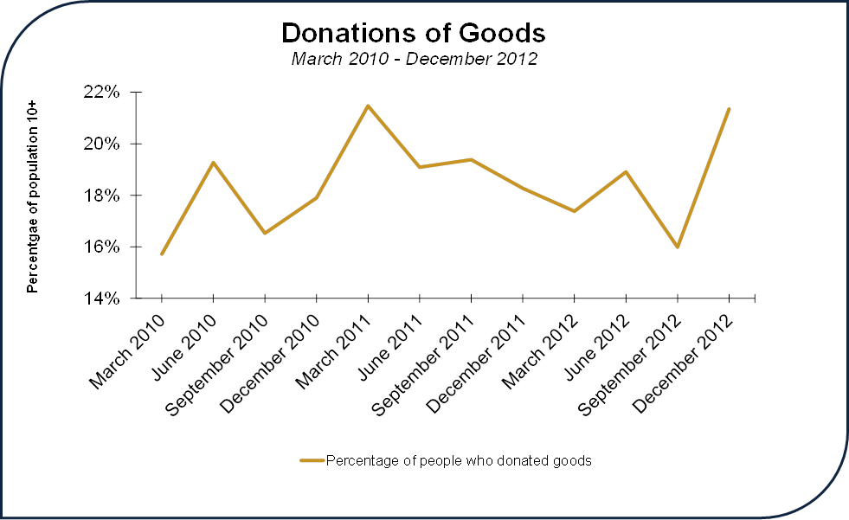
Following a quarter of downward movement, the percentage of the population donating goods rose from 16 per cent in September 2012 to 22 per cent by December 2012.
There is greater volatility in the percentages of people donating goods as compared to people volunteering or donating money.

Gender and Volunteering
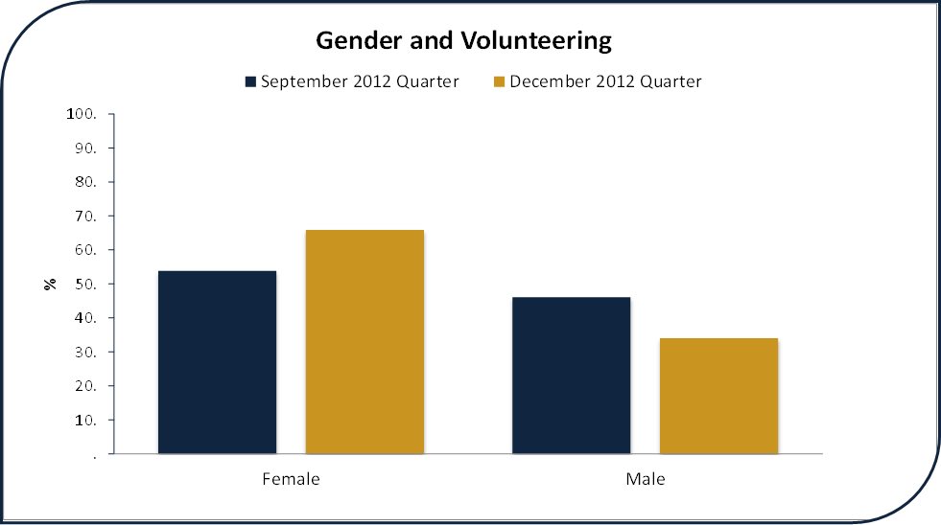
In the December 2012 quarter, approximately 30 per cent of New Zealand’s population 10 years and older mentioned they volunteered at least one hour of their time. Of those who said they volunteered, 66 per cent were females and 34 per cent were males.
When comparing the current quarter with the previous, there was a significant increase in the amount of females volunteering. The percentage of females volunteering in New Zealand increased from 54 per cent in September 2012 to 66 per cent in the December 2012, while the percentage of males volunteering fell from 46 per cent to 34 per cent.

Ethnicity and Volunteering
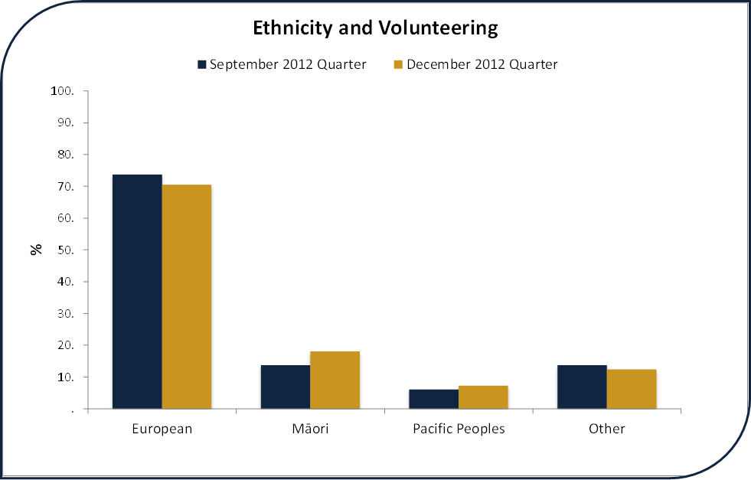
The ethnic profile of respondents who volunteered during the December 2012 quarter roughly aligns with Statistics New Zealand’s ethnic population projections for 2012. This means the ethnic profile of New Zealand volunteers is more or less similar to the ethnic profile of the wider New Zealand population.
It is important to note that different cultures may define 'volunteering' in a variety of ways. For example, Māori define mahi aroha as the unpaid activity performed in accordance with cultural obligations and the principles of tikanga. The different ways that Pacific Peoples and other cultural groups define their unpaid work in their communities may mean that volunteering is under-reported.

Age and Volunteering
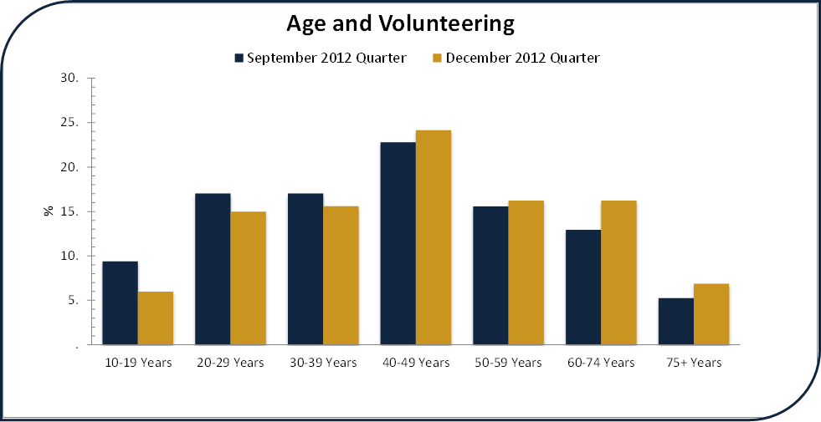
When comparing the volunteering numbers of the September 2012 quarter with the December 2012 quarter, the majority of age groupings are more or less the same with little change occurring between quarters.
People between the ages of 40-49 volunteered more frequently during the December 2012 quarter. As perhaps expected the youngest age group (10-19 years old) and the oldest age group (75 and older) volunteer less frequently than all other age groupings.

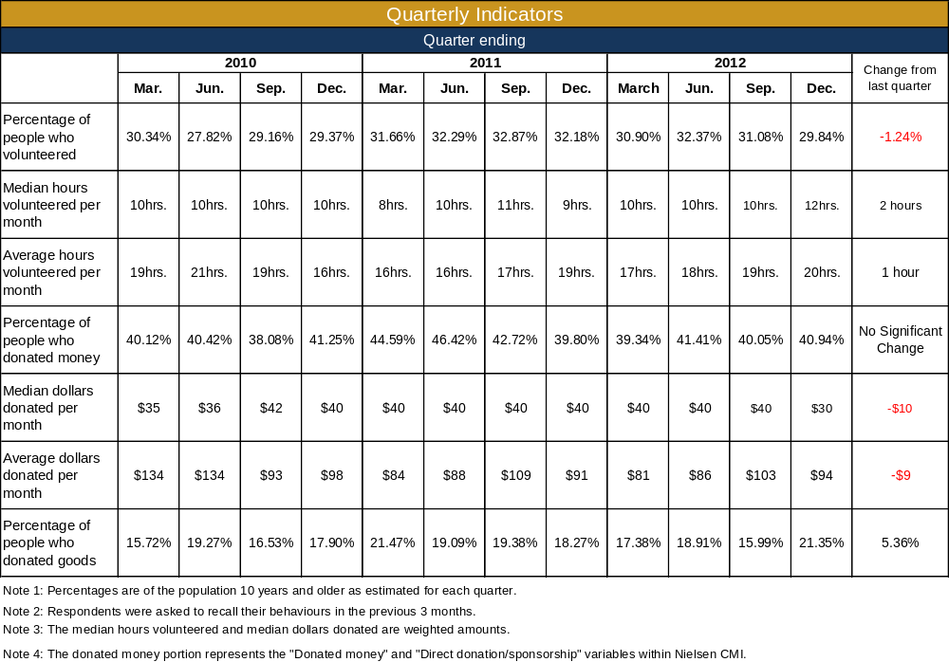

“New Zealand Ethnicity Totals – June 2012” Statistics New Zealand’s Projected Population Estimates, 2006 (base) – 2026.
Office for the Community and Voluntary Sector (2007). Mahi Aroha: Maori Perspectives on Volunteering and Cultural Obligations. http://www.ocvs.govt.nz/documents/work-pragramme/encouraging-participation/volunteering-research/mahi-aroha.pdf

